**NAME: Meet Raut**

**DIV: S2-1**

**ROLL NO: 2201084**

* **EXPERIMENT – 7:**

* ***AIM:*** **To append data to existing file and then display the entire file.**
* ***THEORY:***

**Append Data to Existing File and Display the Entire File:**

In Python, you can use the built-in open() function to open a file in different modes, such as 'r' for reading, 'w' for writing, and 'a' for appending. To append data to an existing file, you can open the file in append mode and then use the write() method to add new content. After appending, you can read and display the entire file.

* **PROGRAM 1:**

file=open('hello.txt','r')

print(file.read())

file=open('hello.txt','w')

file.write("Writing PYTHON LAB\n")

file=open('hello.txt','a')

file.write("Appending an text TSEC\n")

file.close()

* **OUTPUT:**

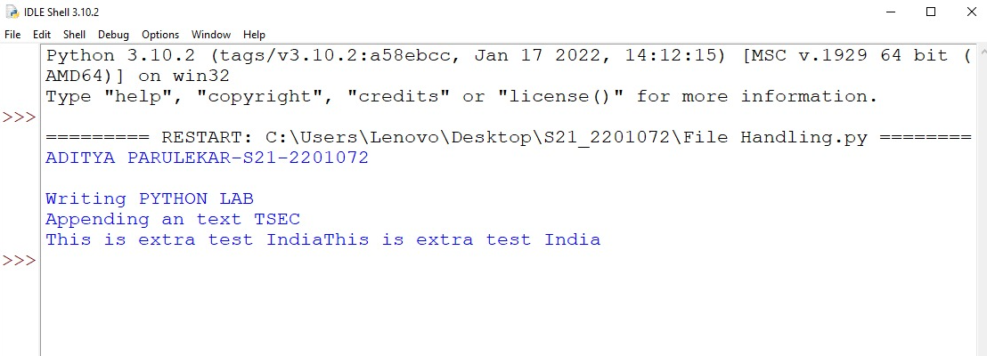

* **PROGRAM 2:**

file1 = open("myfile.txt", "w")

L = ["This is Delhi \n", "This is Paris \n", "This is London"]

file1.writelines(L)

file1.close()

# Append-adds at last

# append mode

file1 = open("myfile.txt", "a")

# writing newline character

file1.write("\n")

file1.write("Today")

# without newline character

file1.write("Tomorrow")

file1 = open("myfile.txt", "r")

print("Output of Readlines after appending")

print(file1.read())

print()

file1.close()

* **OUTPUT:**

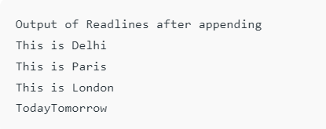

* ***CONCLUSION:*** **Hence, we have successfully implemented program on exploring files and directories; LO 2.**